**Junaid Girkar**

**60004190057**

**TE Comps A4**

**Experiment No. 7**

**Aim:** Query execution on XML Database.

**Theory:**

An **XML database** is a data persistence software system that allows data to be specified and sometimes stored, in XML format. This data can be queried, transformed, exported, and returned to a calling system. XML databases are a flavor of document-oriented databases which are in turn a category of NoSQL databases.

**Types of XML databases**

There are two types of XML databases.

1. XML-enabled database
2. Native XML database (NXD)

**XML-enable Database:**

An XML-enabled database functions in the same way as a relational database. It's similar to an extension that allows you to convert XML documents. Data is kept in this database in the form of rows and columns in a table.

**Native XML Database:**

Large volumes of data are contained in native XML databases. Native XML databases use container format instead of table format. XPath expressions can be used to query data.

Because it is incredibly competent in storing, maintaining, and querying XML content, native XML databases are favored over XML-enabled databases.

**Implementation:**

1. **Creating an XML Table:**

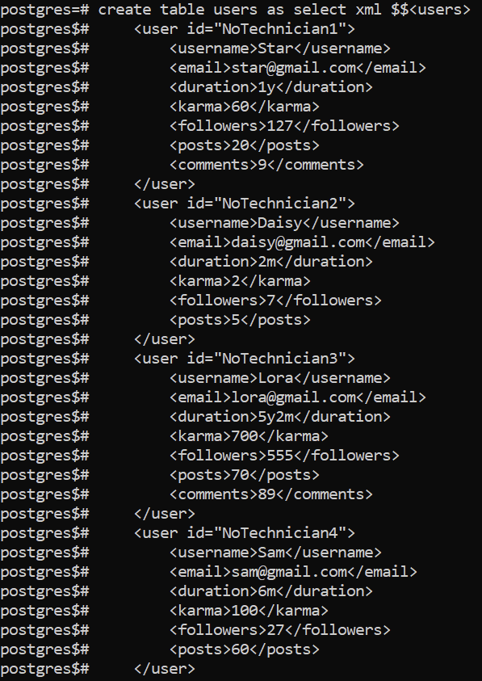

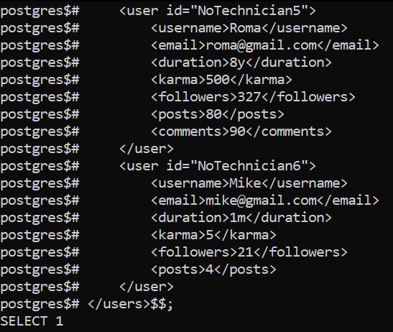

1. **Selecting from Users Table:**

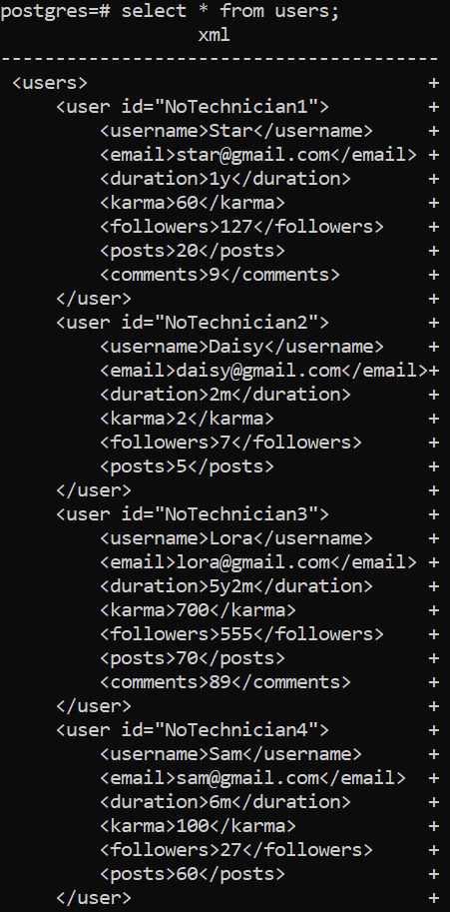

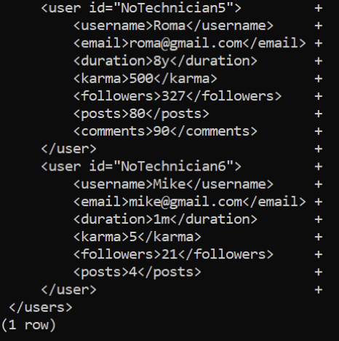

1. **Using xpath to extract data from XML:**

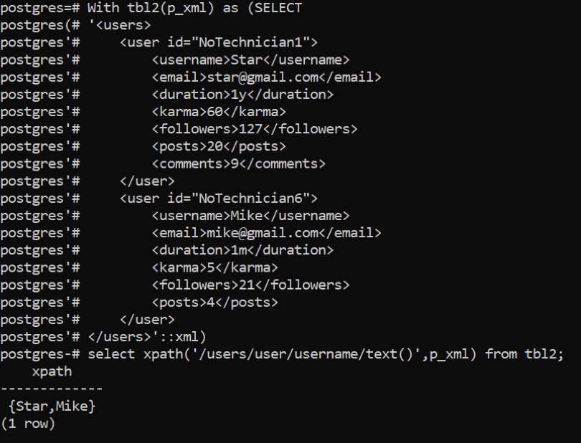

**Conclusion:**

We implemented queries in PostgreSQL database in XML format and conclude that XML Database implementation is very simple and user-friendly.